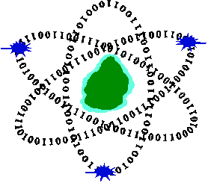
Computer Emergency Response Team of Mauritius
Ministry of Information Technology, Communication and Innovation
CERT-MU Vulnerability Note

Nessus Agent Windows Flaw Enables SYSTEM-Level Code Execution
Vulnerability Note: VN-2026-04
Date of Issue: 27 April 2026
Severity Rating: High
Systems Affected:
- Nessus Agent 11.1.2 and earlier
Description
A vulnerability has been identified in Nessus Agent software for Windows, and this could be exploited by remote attackers to cause execution of malicious code with full system-level privileges. The vulnerability is caused due to improper link resolution before file access, classified under CWE-59 (“Link Following”). On Windows systems, an attacker with local access can create a junction, a type of filesystem shortcut, that tricks the Nessus Agent into deleting arbitrary files using SYSTEM privileges.

Solution

Users are advised to upgrade to Nessus Agent 11.1.3 to address these issues.
The installation files can be obtained from the Tenable downloads portal: https://www.tenable.com/downloads/nessus-agents
References
Tenable
https://www.tenable.com/security/tns-2026-12

gbhackers
https://gbhackers.com/nessus-agent-windows-flaw/
Postal address
Computer Emergency Response Team of Mauritius (CERT-MU)
Ministry of Information Technology, Communication and Innovation
3rd Floor, Wing A,
Shri Atal Bihari Vajpayee Tower,
Cybercity Ebene,

