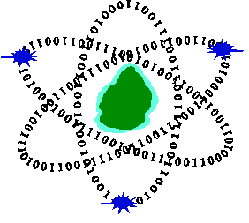
Computer Emergency Response Team of Mauritius
Ministry of Information Technology, Communication and Innovation
CERT-MU Vulnerability Note

Check Point SmartConsole Zero-Day Lets Unauthenticated Attackers Gain Full Admin Access
Vulnerability Note: VN-2026-07
Date of Issue: 29 July 2026
Severity Rating: High
Systems Affected:
- Check Point Security Management Server
- Multi-Domain Security Management Server (MDS)
Description
A critical zero-day vulnerability has been identified in Check Point SmartConsole that could allow unauthenticated attackers to gain full administrative access to affected environments. The vulnerability stems from how SmartConsole handles Secure Internal Communication (SIC)-based authentication across both legacy and modern services.

SmartConsole relies on two primary services: the legacy FWM/CPMI service over TCP port 18190 and the newer CPM/DLE SOAP-based service over HTTPS on port 19009. During authentication, the application improperly trusts attacker-supplied SIC Distinguished Names (DNs) without validating them against authenticated certificate identities.

This design flaw allows remote attackers to impersonate trusted internal components without presenting a valid client certificate.

Solution
Check Point has released patches addressing this issue by enforcing strict validation between supplied SIC DN values and authenticated certificate identities. The updated implementation ensures that remote clients cannot override certificate-derived identities and introduces rejection logic for mismatched or missing credentials.
Organisations using affected versions (R81.20 and R82.10) are strongly advised to apply the latest jumbo hotfixes immediately.
More information is available on:
Vendor advisory (CVE-2026-16232): https://support.checkpoint.com/results/sk/sk185169/

Vendor advisory (CVE-2026-62144): https://support.checkpoint.com/results/sk/sk185152/
Vendor advisory (CVE-2026-62145): https://support.checkpoint.com/results/sk/sk185153/
Postal address
Computer Emergency Response Team of Mauritius (CERT-MU)
Ministry of Information Technology, Communication and Innovation
3rd Floor, Wing A,
Shri Atal Bihari Vajpayee Tower,
Cybercity Ebene,

